Problem Set on Clippers and Clampers
- Find I_{D}, V_{D2} and V_{o}
- Find I, V₁, V₂ and V_{o}
- Find Vo, I_{D1},I_{D2} and I₁
- Sketch the output and find the dc level of the output
- Find the output waveform for each circuit
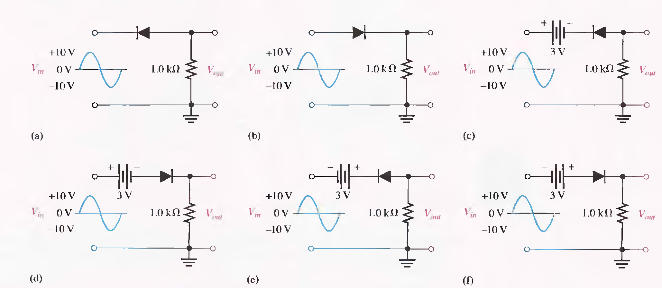

- Find the RL voltage waveform for the following
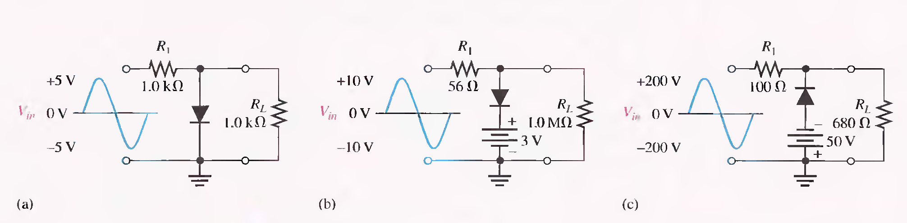
- Determine the output waveform, assuming RC time constant to be much greater than period of the input
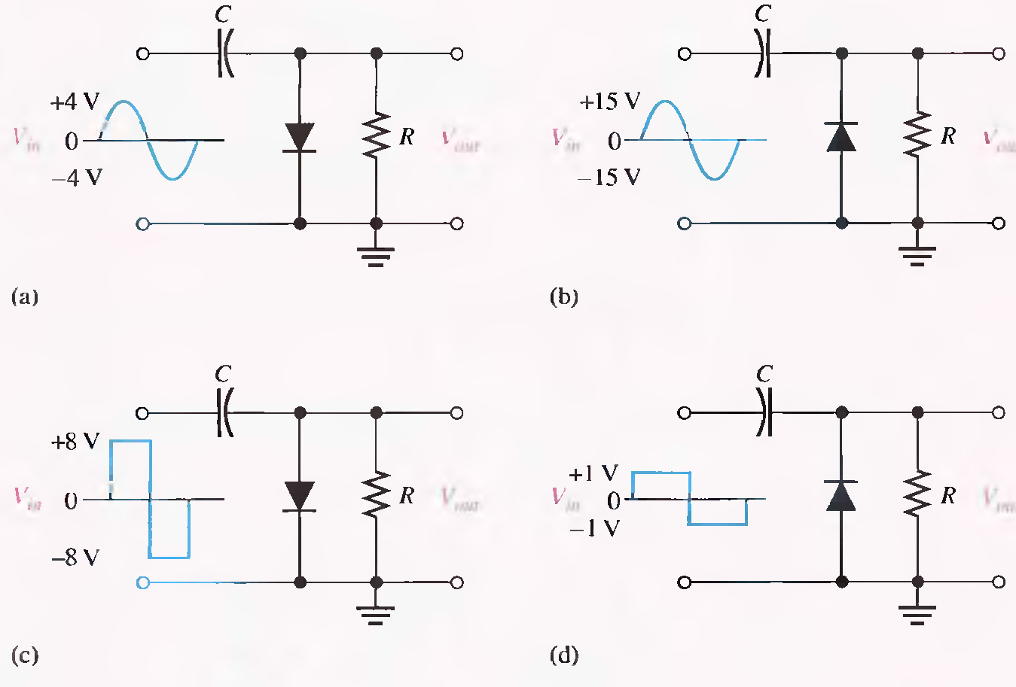

- Sketch the output voltage

- Find i_{R} and V_{o}

- Design a clamper to perform the function as indicated

